K-Nearest Neighbor (KNN) Algorithm for Machine Learning
- K-Nearest Neighbour is one of the simplest Machine Learning algorithms based on Supervised Learning technique.
- K-NN algorithm assumes the similarity between the new case/data and available cases and put the new case into the category that is most similar to the available categories.
- K-NN algorithm stores all the available data and classifies a new data point based on the similarity. This means when new data appears then it can be easily classified into a well suite category by using K- NN algorithm.
- K-NN algorithm can be used for Regression as well as for Classification but mostly it is used for the Classification problems.
- K-NN is a non-parametric algorithm, which means it does not make any assumption on underlying data.
- It is also called a lazy learner algorithm because it does not learn from the training set immediately instead it stores the dataset and at the time of classification, it performs an action on the dataset.
- KNN algorithm at the training phase just stores the dataset and when it gets new data, then it classifies that data into a category that is much similar to the new data.
- Example: Suppose, we have an image of a creature that looks similar to cat and dog, but we want to know either it is a cat or dog. So for this identification, we can use the KNN algorithm, as it works on a similarity measure. Our KNN model will find the similar features of the new data set to the cats and dogs images and based on the most similar features it will put it in either cat or dog category.

Why do we need a K-NN Algorithm?
Suppose there are two categories, i.e., Category A and Category B, and we have a new data point x1, so this data point will lie in which of these categories. To solve this type of problem, we need a K-NN algorithm. With the help of K-NN, we can easily identify the category or class of a particular dataset. Consider the below diagram:
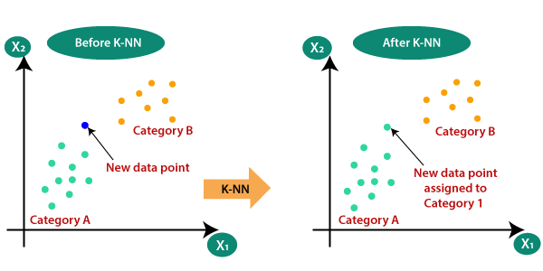

How does K-NN work?
The K-NN working can be explained on the basis of the below algorithm:
- Step-1: Select the number K of the neighbors
- Step-2: Calculate the Euclidean distance of K number of neighbors
- 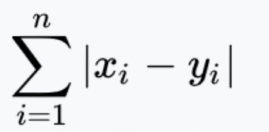
Manhattan
- 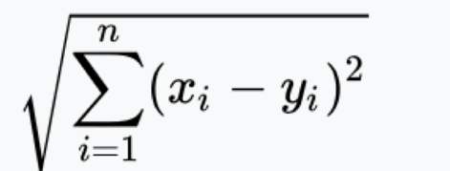
Euclidian
- Step-3: Take the K nearest neighbors as per the calculated Euclidean distance.
- Step-4: Among these k neighbors, count the number of the data points in each category.
- Step-5: Assign the new data points to that category for which the number of the neighbor is maximum.
- Step-6: Our model is ready.
Suppose we have a new data point and we need to put it in the required category. Consider the below image:
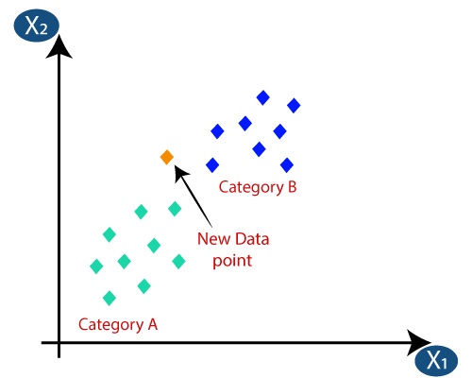
- Firstly, we will choose the number of neighbors, so we will choose the k=5.
- Next, we will calculate the Euclidean distance between the data points. The Euclidean distance is the distance between two points, which we have already studied in geometry. It can be calculated as:
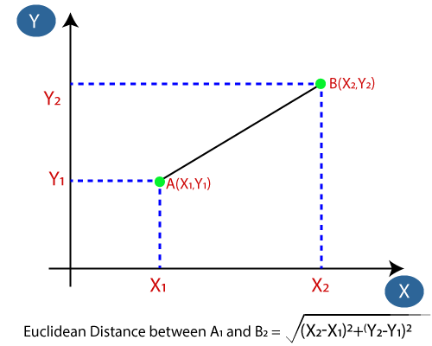
- By calculating the Euclidean distance we got the nearest neighbors, as three nearest neighbors in category A and two nearest neighbors in category B. Consider the below image:
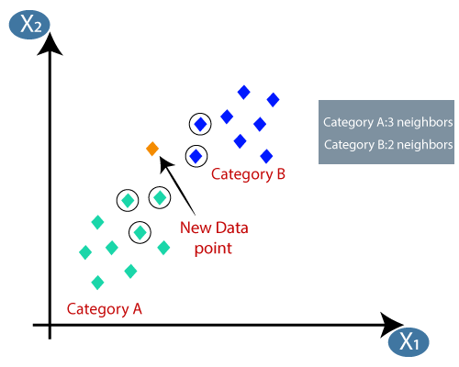
- As we can see the 3 nearest neighbors are from category A, hence this new data point must belong to category A.

How to select the value of K in the K-NN Algorithm?
Below are some points to remember while selecting the value of K in the K-NN algorithm:
- There is no particular way to determine the best value for "K", so we need to try some values to find the best out of them. The most preferred value for K is 5.
- A very low value for K such as K=1 or K=2, can be noisy and lead to the effects of outliers in the model.
- Large values for K are good, but it may find some difficulties.

Advantages of KNN Algorithm:
- It is robust to the noisy training data
- It can be more effective if the training data is large.
- Easy to implement as the complexity of the algorithm is not that high.
- Adapts Easily – As per the working of the KNN algorithm it stores all the data in memory storage and hence whenever a new example or data point is added then the algorithm adjusts itself as per that new example and has its contribution to the future predictions as well.
- Few Hyperparameters – The only parameters which are required in the training of a KNN algorithm are the value of k and the choice of the distance metric which we would like to choose from our evaluation metric.

Disadvantages of KNN Algorithm:
- Always needs to determine the value of K which may be complex some time.
- The computation cost is high because of calculating the distance between the data points for all the training samples.
- Does not scale – As we have heard about this that the KNN algorithm is also considered a Lazy Algorithm. The main significance of this term is that this takes lots of computing power as well as data storage. This makes this algorithm both time-consuming and resource exhausting.
- Curse of Dimensionality – There is a term known as the peaking phenomenon according to this the KNN algorithm is affected by the curse of dimensionality which implies the algorithm faces a hard time classifying the data points properly when the dimensionality is too high.
- Prone to Overfitting – As the algorithm is affected due to the curse of dimensionality it is prone to the problem of overfitting as well. Hence generally feature selection as well as dimensionality reduction techniques are applied to deal with this problem.
Fitting K-NN classifier to the Training data:
Now we will fit the K-NN classifier to the training data. To do this we will import the KNeighborsClassifier class of Sklearn Neighbors library. After importing the class, we will create the Classifier object of the class. The Parameter of this class will be
- n_neighbors: To define the required neighbors of the algorithm. Usually, it takes 5.
- metric='minkowski': This is the default parameter and it decides the distance between the points.
- p=2: It is equivalent to the standard Euclidean metric.
Applications of k-NN in machine learning
- The k-NN algorithm has been utilized within a variety of applications, largely within classification. Some of these use cases include:
- - Data preprocessing: Datasets frequently have missing values, but the KNN algorithm can estimate for those values in a process known as missing data imputation.
- - Recommendation Engines: Using clickstream data from websites, the KNN algorithm has been used to provide automatic recommendations to users on additional content. This research (link resides outside ibm.com) shows that the a user is assigned to a particular group, and based on that group’s user behavior, they are given a recommendation. However, given the scaling issues with KNN, this approach may not be optimal for larger datasets.
- - Finance: It has also been used in a variety of finance and economic use cases. For example, one paper (link resides outside ibm.com) shows how using KNN on credit data can help banks assess risk of a loan to an organization or individual. It is used to determine the credit-worthiness of a loan applicant. Another journal (link resides outside ibm.com) highlights its use in stock market forecasting, currency exchange rates, trading futures, and money laundering analyses.
- - Healthcare: KNN has also had application within the healthcare industry, making predictions on the risk of heart attacks and prostate cancer. The algorithm works by calculating the most likely gene expressions.
- - Pattern Recognition: KNN has also assisted in identifying patterns, such as in text and digit classification (link resides outside ibm.com). This has been particularly helpful in identifying handwritten numbers that you might find on forms or mailing envelopes.

The KNN Algorithm steps

Load the data
- Initialize K to your chosen number of neighbors
- For each example in the data
- Calculate the distance between the query example and the current example from the data.
- Add the distance and the index of the example to an ordered collection
- Sort the ordered collection of distances and indices from smallest to largest (in ascending order) by the distances
- Pick the first K entries from the sorted collection
- Get the labels of the selected K entries
- If regression, return the mean of the K labels
- If classification, return the mode of the K labels

